**Ideation Phase**

**Defining Project Goals**

|  |  |
| --- | --- |
| Date | 28 JUNE 2025 |
| Team ID | LTVIP2025TMID59766 |
| Project Name | **TrafficTelligence: Advanced Traffic Volume Estimation with Machine Learning** |
| Maximum Marks | 4 Marks |

The main goal of this project is to identify hazards and risks and provide a summary of your current controls to eliminate and/or reduce them as far as practical. The plan should form the basis of training for all workers, contractors and others and should be provided to all through the relevant inductions.

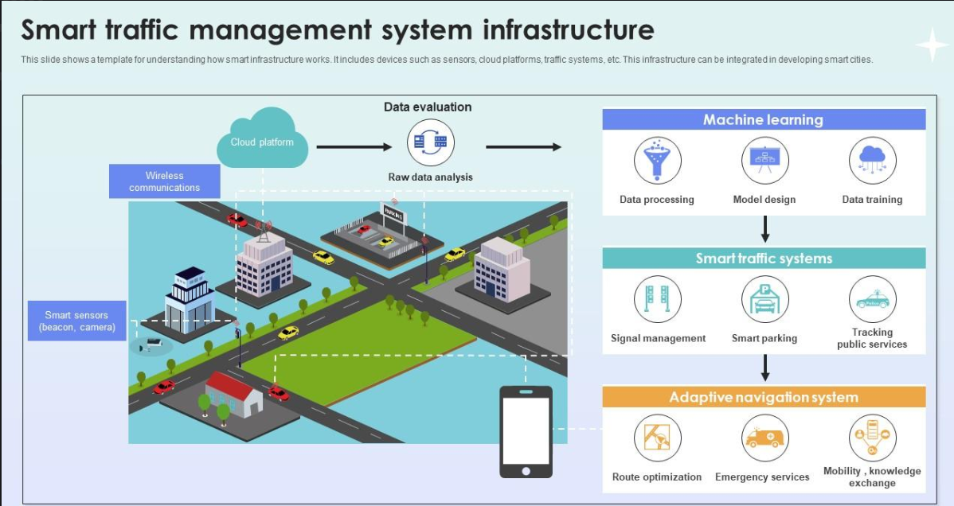

* **Predict Traffic Volume**  
  Use machine learning to accurately forecast future traffic conditions.
* **Improve Traffic Management**  
  Help authorities optimize traffic signals and reduce congestion.
* **Enhance Commuter Experience**  
  Provide timely traffic insights to help commuters plan better routes.
* **Support Urban Planning**  
  Offer data-driven insights for better road and infrastructure planning.
* **Enable Smart Decision-Making**  
  Use real-time and historical data to make proactive traffic decisions.